Lab EBS
Creating and Attaching an EBS Volume
- Launch awslinux type resource
- Go to volume and check which availably zone volume has created
- EC2->Volume section
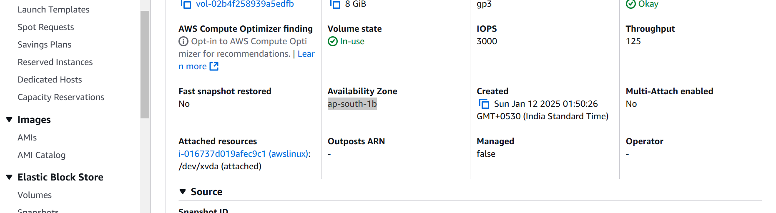

1. Create an EBS Volume:
- Go to the AWS Management Console.
- Navigate to the EC2 Dashboard.
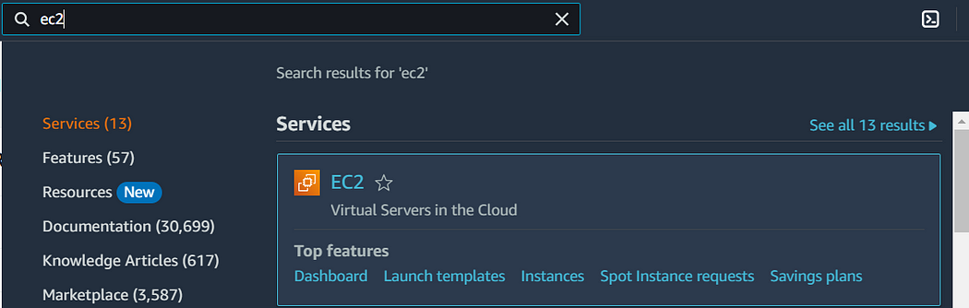
- Click on “Volumes” under “Elastic Block Store”.
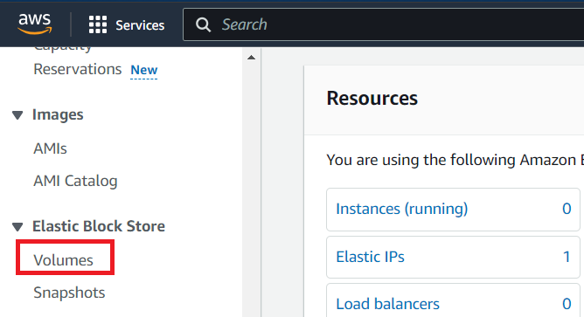
- Click “Create Volume”.
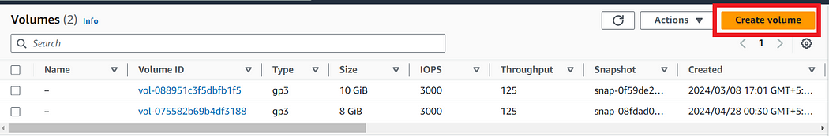
- Specify the volume type, size, and availability zone, then click “Create Volume”.
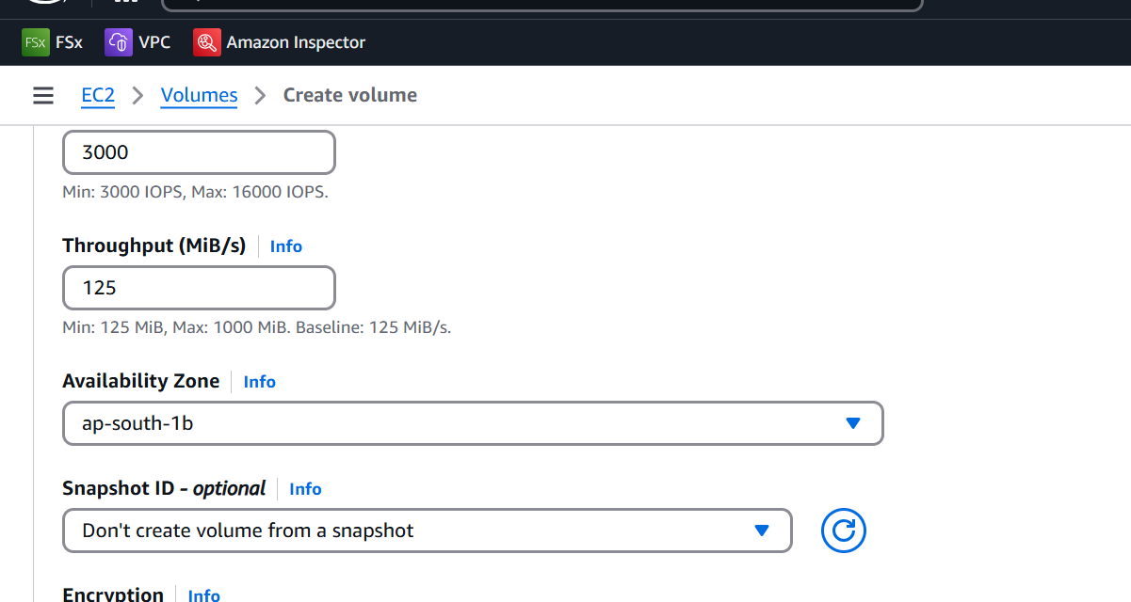
2. Attach the EBS Volume to an Instance:
- Select the newly created volume from the “Volumes” list.
- Click on “Actions” and select “Attach Volume”.
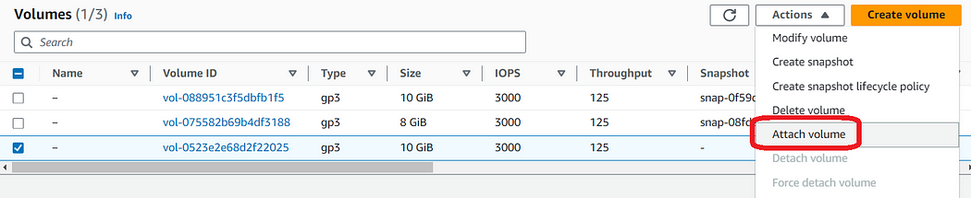

- Choose the instance to attach the volume to and specify the device name (e.g., /dev/sdf), then click “Attach Volume”.
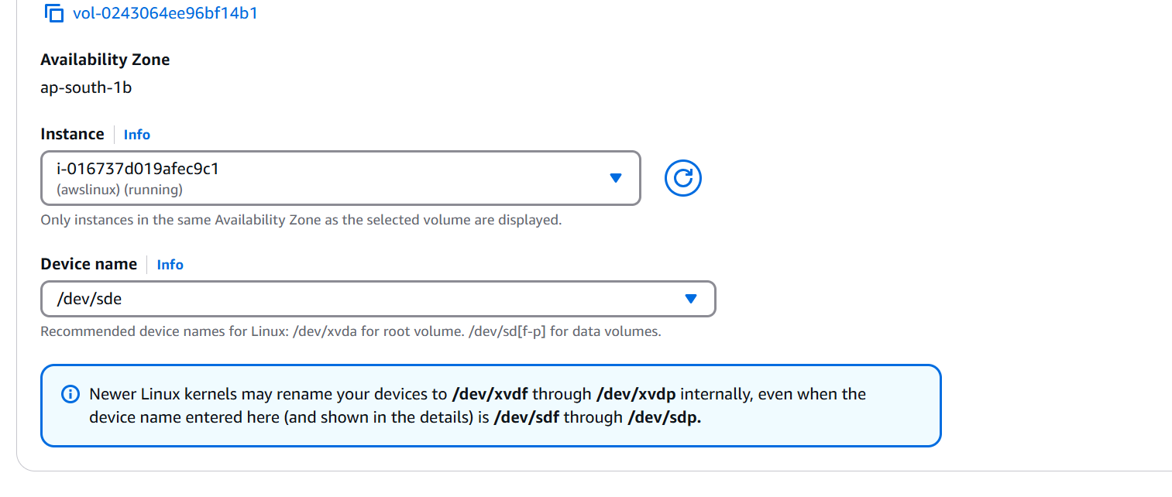
- Since the Volume is created in us-west-1a Availability zone, it will automatically detect all the instances in same availability zone. (EBS is AZ service).
3. Formatting and Using the EBS Volume
- Connect to the EC2 Instance:
- Use SSH to connect to your EC2 instance.
2. Format the EBS Volume:
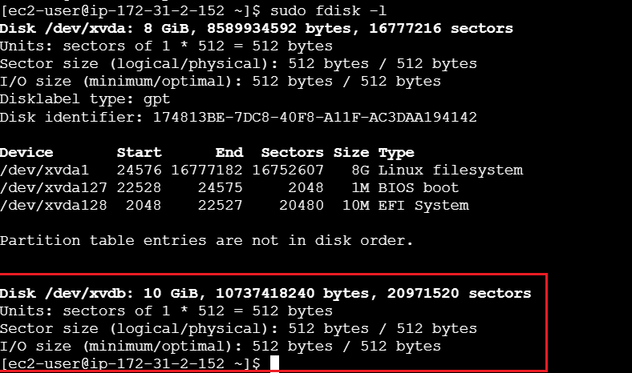
sudo mkfs.ext4 /dev/xvdb
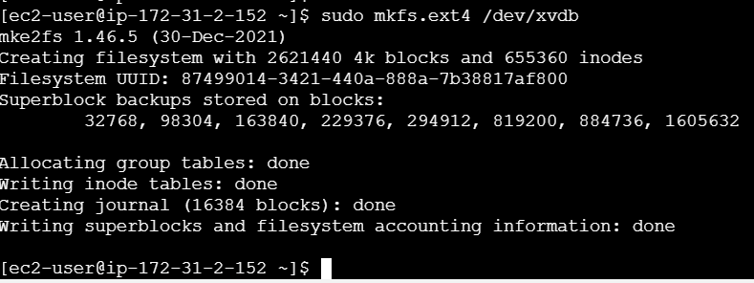
3. Mount the Volume:
sudo mkdir /data
sudo mount /dev/xvdb /data
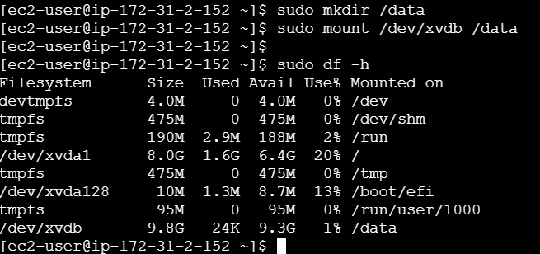
4. Store Data:
- You can now store data in the /data directory.
sudo cd /data
touch a
touch b

4. Create a Snapshot:
- Go to the “Volumes” section in the EC2 Dashboard.
- Select the volume, click “Actions”, and then “Create Snapshot”.
- Provide a description and click “Create Snapshot”.
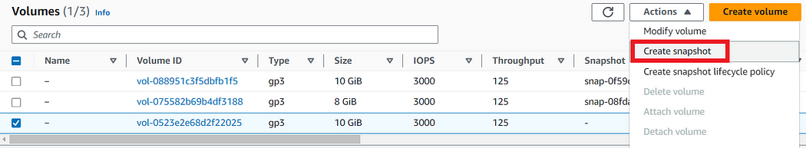
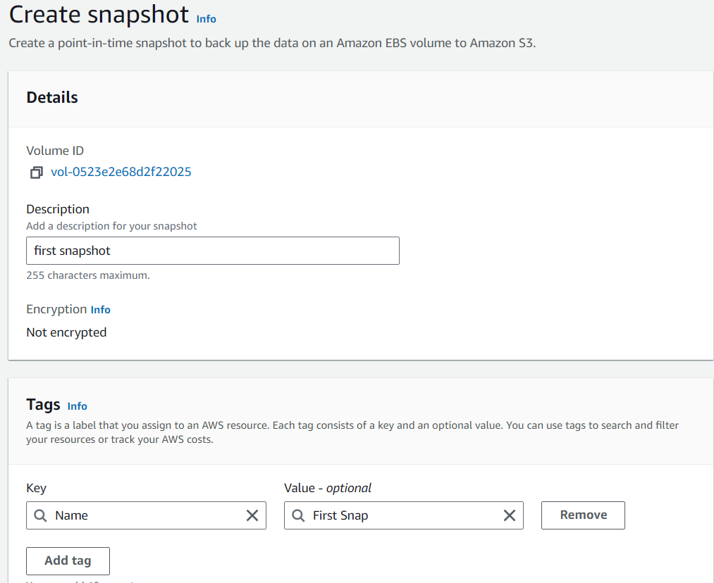
5. Create a Volume from a Snapshot:
- Go to the “Snapshots” section.
- Select the snapshot, click “Actions”, and then “Create Volume”.
- Specify the new volume details, including the availability zone, and click “Create Volume”.
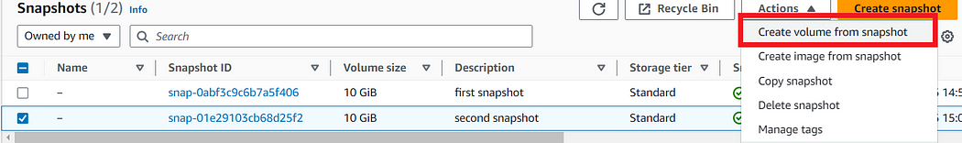
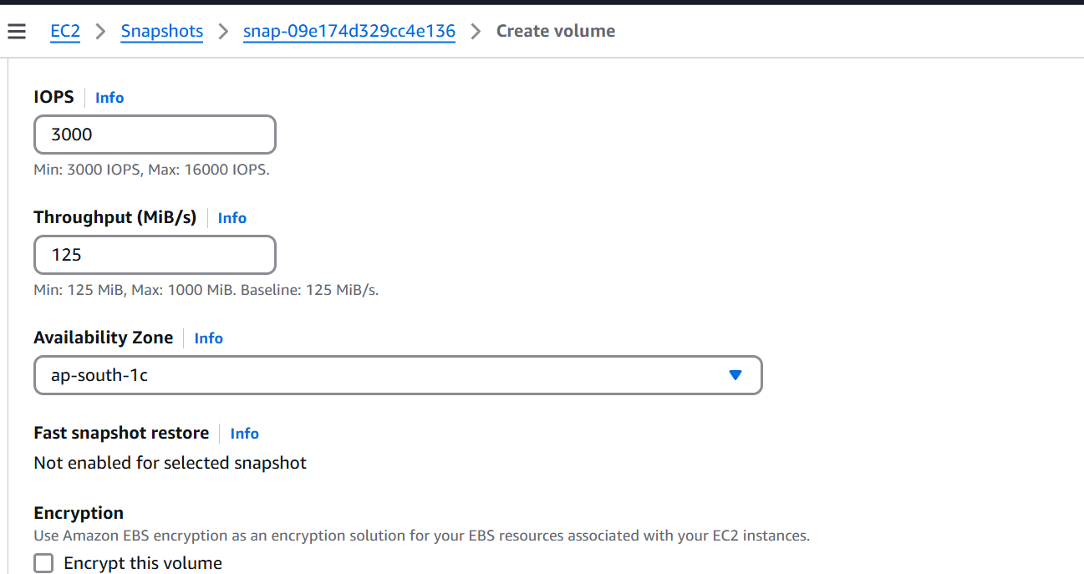
- Choose the Availability zone where you want to create that volume.
- We have choose ap-south-c
6. Verification:
- After this Attach this volume to other instance in us-south-c
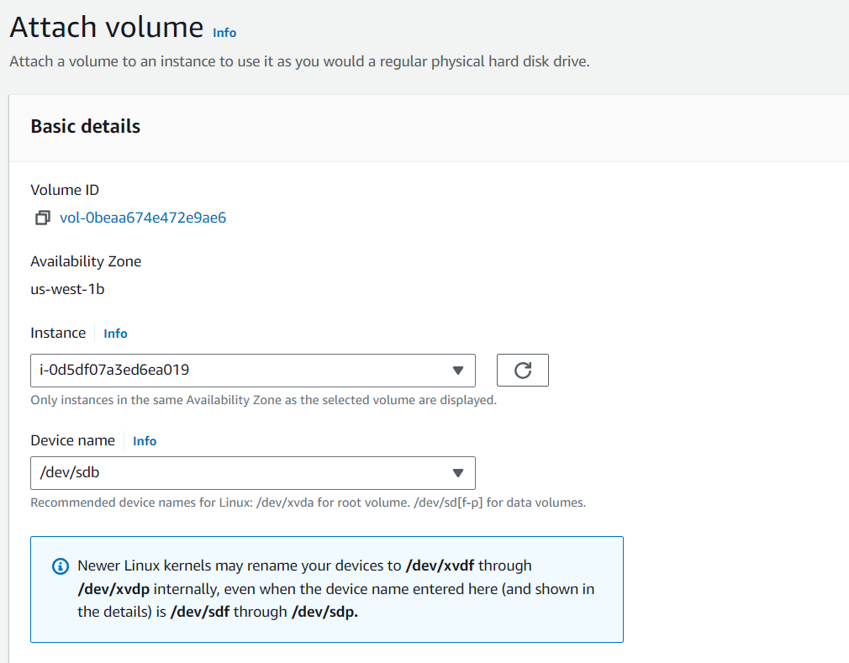
- Connect to that instance and mount the volume to /mydata folder.
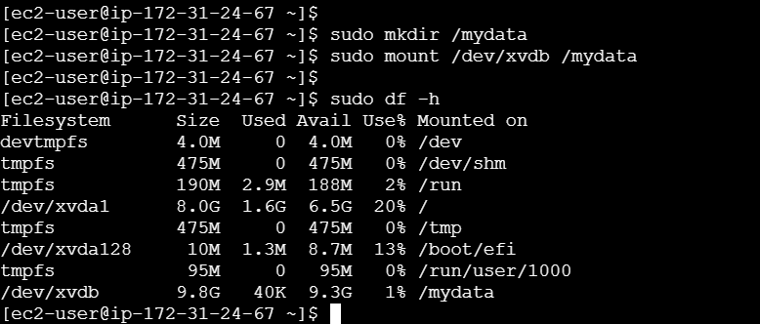
- And see whether the same data is present or not.

- Hence the verification is successful.

